# Use-Case

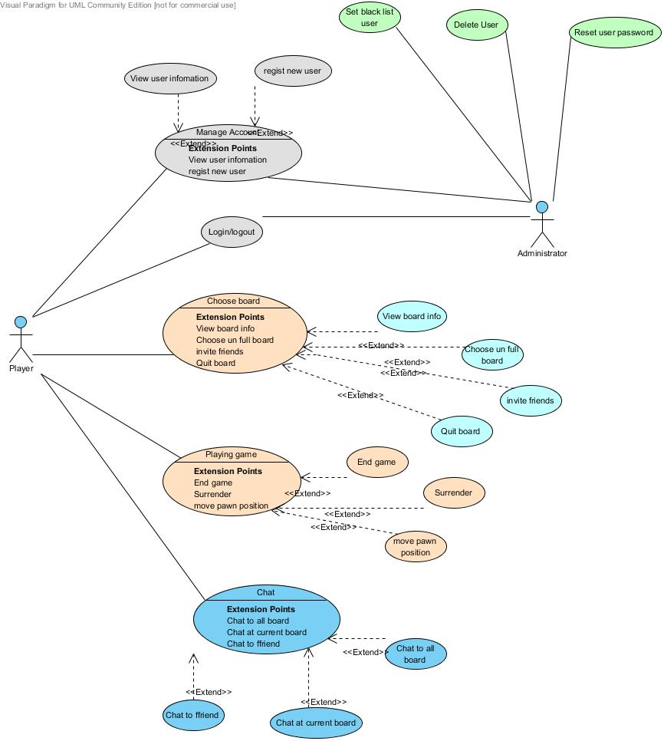

# Accounts Control

# Login

**Brief description**

This use case describes how a user login to the Game COTOAN online

**Flow of Events**

**Basic flow**

This use case starts when actor wishes to login to game COTOAN online

1. The actor enter his/her name and password
2. The info will push to server and wait response from server

**Alternative flows**

1. Invalid username/password

If in the basic flow, the actor enters an invalid username / password, the server will response an message which show the error when login to client game.

1. Lose connector to server

Display error in connect to server.

**Special requirement**

None

**Pre-conditions**

Connect to server success

**Post-conditions**

If the use case was successful, the user is now logged into the system. If not, the system state is unchanged.

**Extension points**

None

# Logout

**Brief description**

This use case describes how a user can log out the game cotoan online

**Flow of Events**

**Basic flow**

this use case starts when the actor wishes to log out the Game COTOAN online

The user click the logout button

**Alternative flow**

**none**

**Special requirements**

none

**Pre-conditions**

The Game client is in login state

**Post-conditions**

If the user case was success ful, the user is now logged out the game COTOAN client. If not, the user is still logged

**Extension points**

None

# View User info

**Brief description**

This use case allows a user and administrator view all information of user. Otherwise, user can be seen part of information of other user and that it is public user want to show. Furthermore, profile could update information automatic, and then it was save by server. Profile could edit, modify by that user or administrator.

**Flow of Events**

**Basic flow**

User should register to Game server. After that user must fill in all blanks flow requirements of this page and sure that is correct information. All information will save by game server and user can accept profile to update, change something if that is need. Game server update information of profile into database and user, another user, administrator can be view the profile.

**Alternative flow:**

Users edit their information: if in the basic flow, the users change their information, then saving those changes. The game server saves those changes in database.

**Special requirements**

user should declare correct email because system will send a mail to that email address. Viewer should accept email and click link to active account.

**Pre-conditions**

User must loged in the game client - server

**Post-conditions**

none

**Extension points**

None

# Set black list user

**Brief description**

This use case allow administrator set a user to black list which include some user who did not have permission to playing game

**Flow of Events**

**Basic flow**

**Alternative flows**

**none**

**Special requirements**

none

**Pre-conditions**

Administrator must logged into the game server

**Post-conditions**

This use will not have able to playing game cotoan online

**Extension points**

None

# Manage Account

**Brief description**

This use case describes how the Administrator manages user account on game server such as delete, create new user, view user information or reset passwords.

**Flow of Events**

**Basic flow**

This use case starts when the Administrator wishes to view user information, create new user account ,delete accounts or reset passwords

1. Administrator request the user in Database to game server

2. The new information will be fill to the user information form, save this to the database

If the Administrator selected “View User Profile” button, the “View User Profile” sub flow is executed.

If the Administrator selected “Create new User Account” button, the “Create new User Account” sub flow is executed

If the Administrator selected “Delete Account” button, the “Delete account” sub flow is executed.

If the Administrator selected “Reset password” button, the “Reset password” sub flow is executed.

**Sub flows:**

View User Profile:

1. The user profile will be display(not include user’s password)

Create new User Account:

1. The register form will be display
2. Administrator/ user must fill some import fields and maybe fill some unimportant fields.
3. Choose save button to push information to game server.
4. The Game server response to the Game client, game client display result

Delete an Account :

1. The Game server should be confirmed by the Administration

2. The Game server removes this account from the database.

Reset password:

1. The system should be confirmed by the Administration

2. New password will be sent to the account’s mail

**Special requirements**

None

**Pre-conditions**

The Administration must logged in.

**Post-conditions**

The new information will be save to Database on game server

**Extension points**

None

# Choose board

# Choose board

**Brief description**

**Flow of Events**

**Basic flow**

**Special requirements**

**Alternative flows**

The chosen board is full, user will be kick out of board

**Pre-conditions**

1. User logged to the Game client
2. The board is not full

**Post-conditions**

**Extension points**

None

# Invite friends

**Brief description**

**Flow of Events**

**Basic flow**

This use case starts when user logged in a board, the user will send a request invite to the Game server, the game server will send invite request to the other player

**Special requirements**

**None**

**Pre-conditions**

User logged to the Game client

**Post-conditions**

None

**Extension points**

None

# Quit board

**Brief description**

**Flow of Events**

**Basic flow**

This use case starts when user want to quit current board and view all boards.

The Game client will be send request quit board to Game server, the game server will return the information of all board in this system.

**Special requirements**

None

**Pre-conditions**

User logged to the Game client, logged at a board

**Post-conditions**

User quit from current board

**Extension points**

None

# Playing Game

# Play game

**Brief description**

This use case is an action of actor who wants to change the position on pawn or eat another pawn

**Flow of Events**

**Basic flow**

This use case starts when user have new turn, the user must move one of their pawns.

The request move pawn will be send to the Game server, the Game server will return the result of this turn. The Game client display the result.

**Special requirements**

The logic of the game still correct for this actor

**Pre-conditions**

1. This user have his turn and he/her do not pick timeout for this turn
2. The connection to the game server is okay

**Post-conditions**

The Game Client displays new change of the board

**Extension points**

None

# Surrender

**Brief description**

This use case allows user surrender other player

**Flow of Events**

**Basic flow**

This use case starts when actor wishes to surrender other player

The user will choose “Surrender” button, the Game client will send request surrender to the Game server, the game server will be check the logic game and save the information of this game session. The Game server will be return the response to the game client. The game client display the result and move user to choose room frame.

**Special requirements**

none

**Pre-conditions**

This game is playing and the connection to game server okay

**Post-conditions**

The rate of user will be change and update on game server

**Extension points**

None

# Chat box

**Brief description**

This use case allows user can send messages to other friend or to other boards

**Flow of Events**

**Basic flow**

This use case starts when actor wishes to:

1. Send chat to online friend

* The user must chose friend by push the friend name to friends name box. After that, user type message to the Messages Box. Chose send to send Message to friend
* The message will be send to Game server, the game server will be check the friend, if friend is online the message will be sending, else if the friend is not online the message will be dropt, the user will be receiver an response.

1. Send chat to board

* The user must chose board by push the board number to box number. After that, user type message to the Messages Box. Chose send to send Message to board
* Chose box number is 0 to send all box
* The message will be send to Game server, the game server will be send this message to all board

**Special requirements**

none

**Pre-conditions**

User must logged into the game client

**Post-conditions**

User will be chat to others

**Extension points**

None

# End game

**Brief description**

This use case allows user can end game when game is playing

**Flow of Events**

**Basic flow**

This use case starts when actor wishes to end the current game which is playing, the winner will be the other player

1. **User** chose “End game” button, the request end game will be send to the Game server, the game server will be check the logic condition and return response to the Game client.
2. IF connection is lose in while the game client is waiting response, the game client will be auto logout and display error message.

**Special requirements**

None

**Pre-conditions**

The game is playing

**Post-conditions**

Quit this session

**Extension points**

None